A. Cell division
- What is mitosis?
- What are the three main stages of the cell cycle?
- List the 4 stages involved in mitosis, starting with prophase.
- Why is mitosis important to the organism?
- How many daughter cells are formed as a result of mitosis?
- How many chromosomes are present in a human diploid cell?
- What is cancer?
- What is the definition of growth?
- Does cell elongation occur in animal or plant growth?
- What is cell differentiation?
- If a baby was described as being on the 50th percentile for head circumference– what does that mean?
- What is a stem cell?
- How is a human embryonic stem cell different to an adult stem cell?
- Where is a meristem found?
- What is a meristem?
- Name a benefit and a risk to using stem cells in medicine.
- In what stage of an animal’s life cycle do most cells differentiate?
- In mature animals when do cells still need to differentiate?
- In what stage of their life cycle do plant cells differentiate?
B. The central nervous system – brain and scanning
- Name the three main parts of the brain and state the role of each.
- What is a CT scan?
- What is a PET scan?
- What does a PET scan do?
- What are the limitations in treating damage and disease in the brain and nervous system?
C. The central nervous system – neurones and reflex arc
- What is a stimulus?
- What is a receptor?
- Name the two parts of the central nervous system.
- What is an effector?
- What does the CNS coordinate?
- Put these in the correct order: receptor, stimulus, response, coordinator, and effector.
- What is the role of the sensory neurone?
- What is the role of the relay neurone?
- What is the role of the motor neurone?
- What is a synapse?
- Describe what happens at the synapse.
- Why are reflex actions important?
- Recall the pathway of the reflex arc.
- Complete the missing parts of the table below:
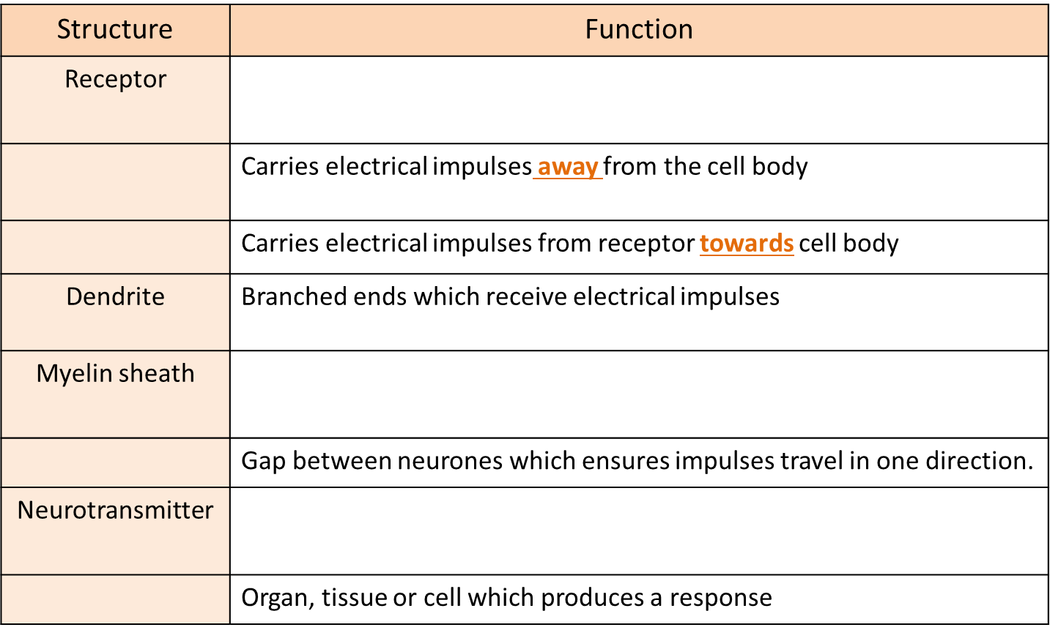
D. The central nervous system – the eye BIOLOGY ONLY
- Label parts A – I on the diagram below:
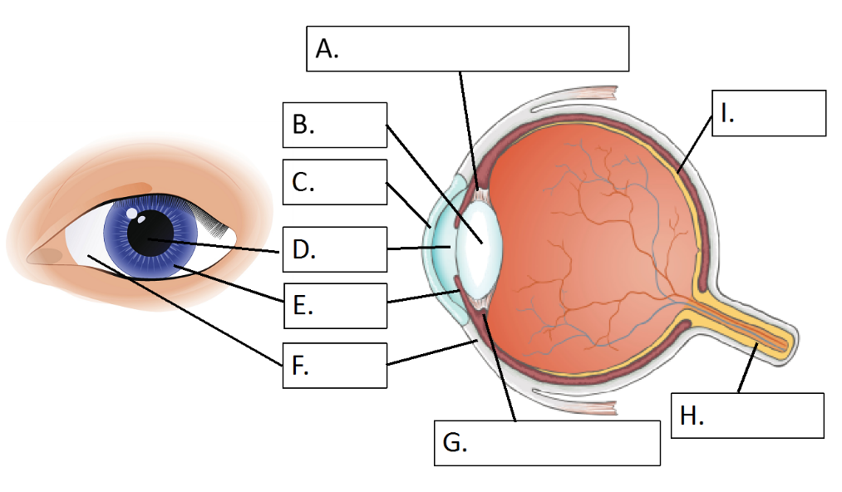
- Complete the table below:
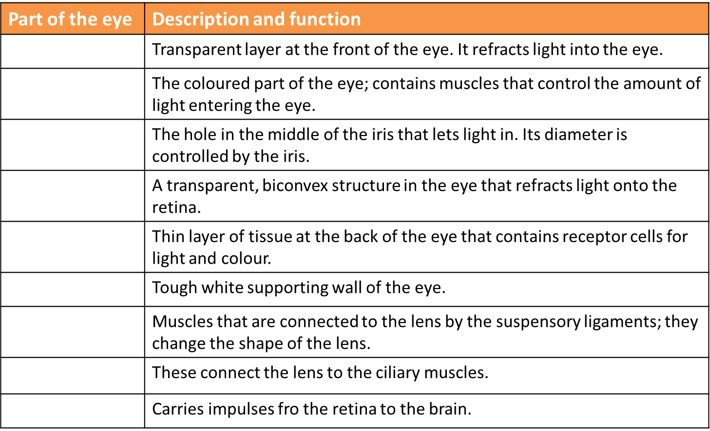
- What is accommodation?
- How does the eye focus on distant objects?
- How does the eye focus on near objects?
- What is myopia? How can it be corrected?
- What is hyperopia? How can it be corrected?
- What is a cataract? How can it be treated?
- What is the most common form of colour blindness?
- What causes colour blindness?

